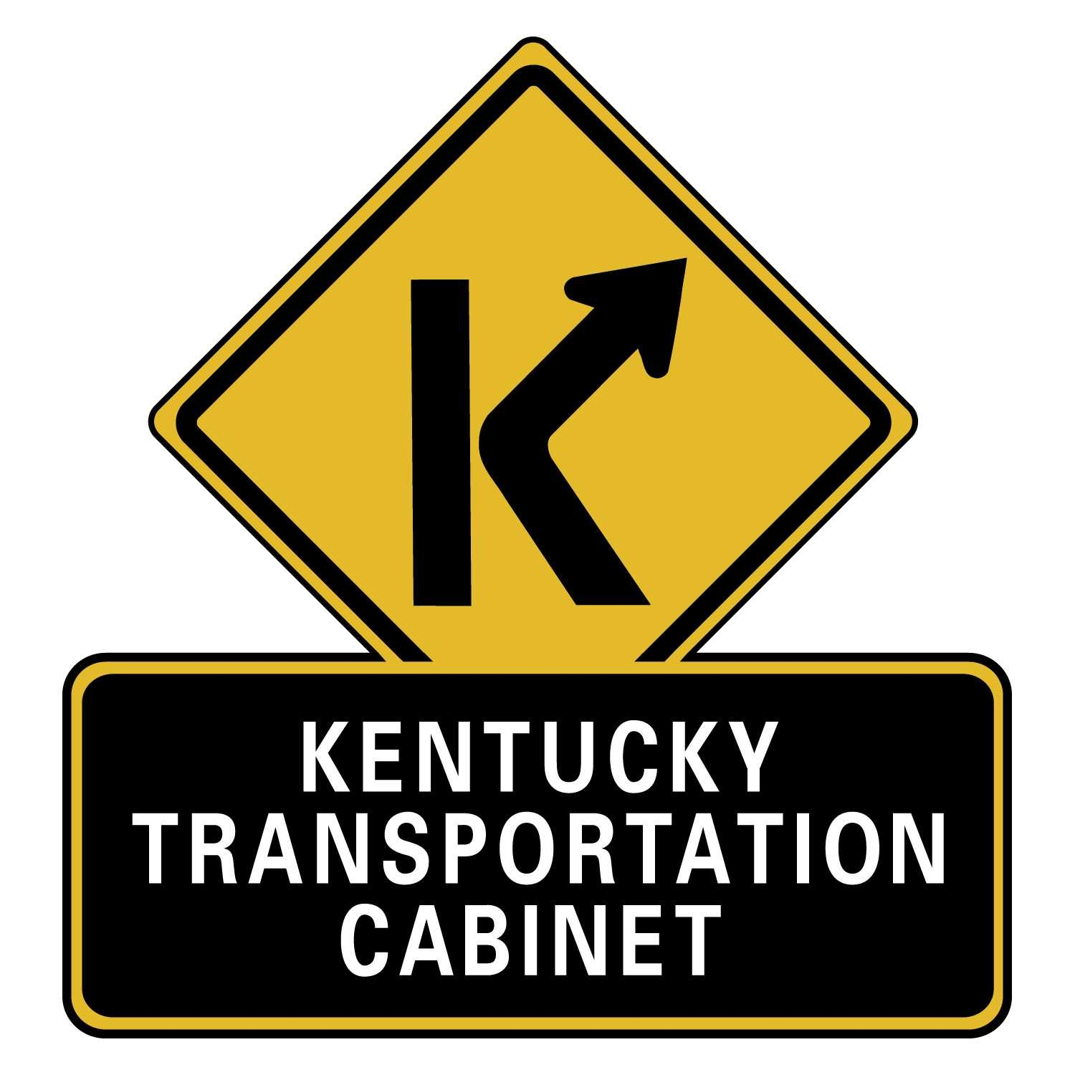
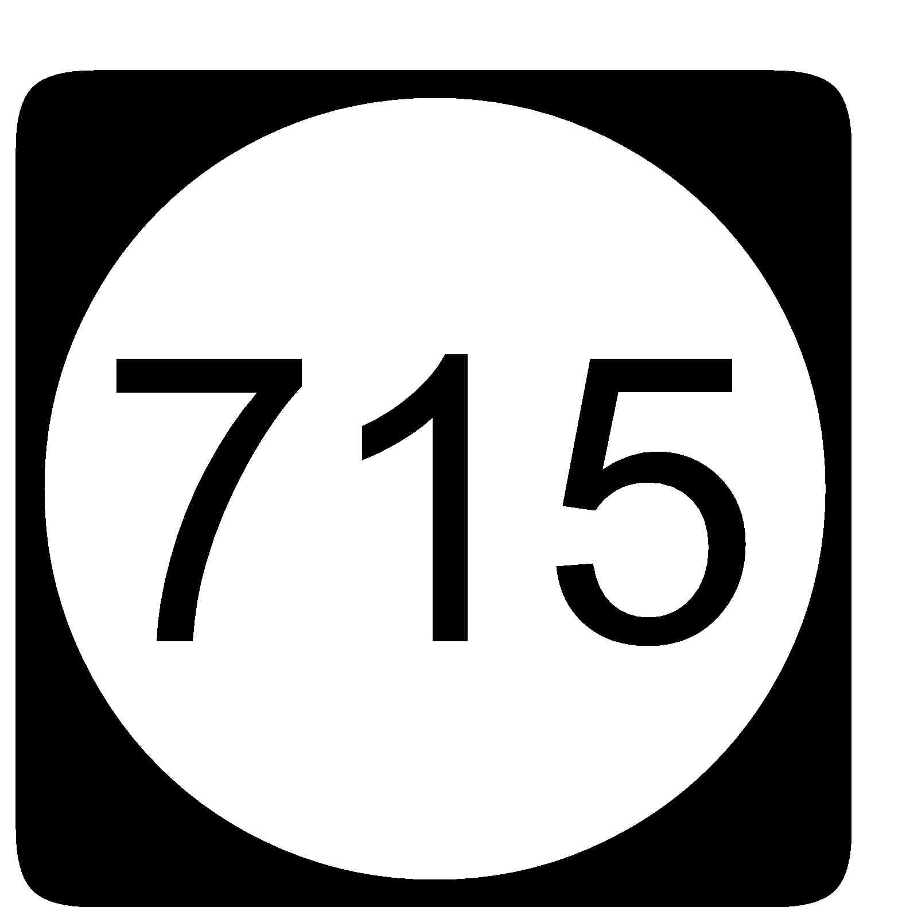
SURVEY QUESTIONNAIRE
What is your opinion about improvements
to KY 715 in Wolfe County?

Public Meeting
Rogers Elementary
Rogers, Kentucky
October 7, 2008
5:00 p.m. – 7:00 p.m. (Open House)

You can help us better understand transportation problems, issues, and potential impacts for proposed improvements to KY 715 in Wolfe County from KY 11 near Zachariah to the Mountain Parkway. The Kentucky Transportation Cabinet will use your input to evaluate the nine (9) alternatives and twelve (12) spot improvements developed for KY 715.
Please return this form before leaving the meeting, or request a postage paid envelope today and return the questionnaire by mail no later than two weeks after the meeting date.
Survey Number: __ W ___
Your Name: Date:
Representing what organization (if any):
Street Address, PO Box, or Other:
City, State, Zip Code:
Phone (optional)

** PLEASE REVIEW THE MAPS OF ALTERNATIVES BEFORE COMPLETING THIS SURVEY. **
- Do you feel that KY 715 needs to be improved? (Check one.) ____ YES ____ NO
- Pick the first and second choice alternatives that you prefer for KY 715? (Write 1 for first choice and 2 for second choice in the box.)
Please refer to the alternative maps to complete this question.

- Alternative A: Improve KY 715 along the existing roadway.
- Alternative B: Improve along existing KY 715 but with new bypass around Rogers.
- Alternative C: Combination of new route from KY 11 to existing KY 715 (north of KY 2016) and then improve along existing KY 715.
- Alternative D: Combination of new route from KY 11 to existing KY 715 (north of KY 2016), new Rogers bypass, and improvement along existing KY 715.
- Alternative E: Completely new route located to the east of existing KY 715.
- Alternative F: Combination of improvements along existing KY 715 from KY 11 to KY 2016 and then a new route east of existing from KY 2016 to KY 15.
- Alternative G: Combination of new route east of existing from KY 11 to KY 2016 and improvements along existing KY 715 from KY 2016 to KY 15 .
- Alternative H (Spot Improvements): Fix all or some of the “spot improvement locations”. (see Question #4 on next page)
- Alternative X: No improvements to KY 715.

- Why do you prefer the alternatives chosen in Question 2?

- In case no new construction or reconstruction is done on KY 715, the Transportation Cabinet may decide to do spot improvements on the existing road (this is Alternative X). Which five (5) spot improvements do you feel are the most needed? (Please write 1 in the box for your first choice, 2 for your second choice, 3 for your third choice, 4 for your fourth choice, and 5 for your fifth choice.)
Please review “Proposed Spot Improvements” map before completing this question.

- Spot S-1:Includes KY 11 and Trentville Road Intersections
- Spot S-2: Includes Cable Ridge Road Intersection
- Spot S-3: South of entrance to Cliffview Resorts
- Spot S-4: North of entrance to Cliffview Resorts
- Spot S-5: Includes intersection with Leg Ridge Road
- Spot S-6: Includes intersection with Kincaid Road and KY 2016

- Spot S-7: South of Glencairn Road
- Spot S-8: Includes Glencairn Road Intersection
- Spot S-9: Includes Tar Ridge Road Intersection
- Spot S-10: Includes Booth Road Intersection
- Spot S-11: Includes KY 15 Intersection
- Spot S-12: Mountain Parkway Interchange (Exit #40)

- Why do you prefer the spot improvement(s) chosen above?

- Are there any other locations where spot improvements should be considered?

- Are there any issues or concerns that you have with any of the proposed alternatives?

If you did not receive a postage paid envelope, please send your survey or any written comments to:
David Martin, P.E., Project Manager, KYTC Division of Planning, 200 Mero Street, Mail Code W5-05-01, Frankfort, KY 40622.
David can also be reached at (502) 564-7183 or Charles.Martin@ky.gov

You may also look for project information on the Kentucky Transportation Cabinet’s
Division of Planning web site at http://www.planning.kytc.ky.gov

